# Lab Manual

Packet Tracer is used in this demo.

Make sure you have the VMware link and test your login: <https://mi-stud-esx-vcenter.students.sunitafe.edu.au/ui/>

1. Open the GUI of Wi-Fi router device
2. Enable remote management

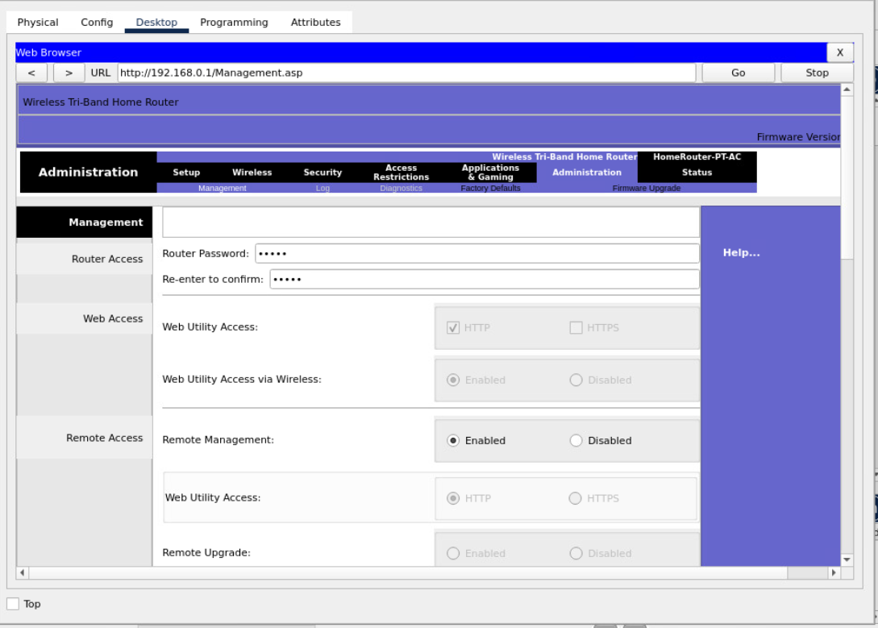

Please SAVE your setting so that it can effect.

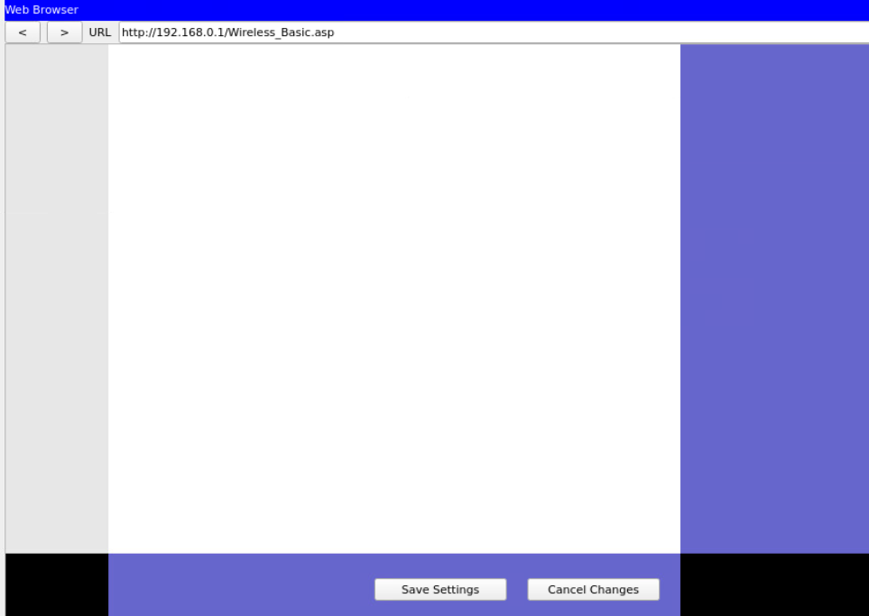

1. Open a wireless user device (tablet, laptop, phone, etc.), the one that is connected to the Wi-Fi router without any setting.

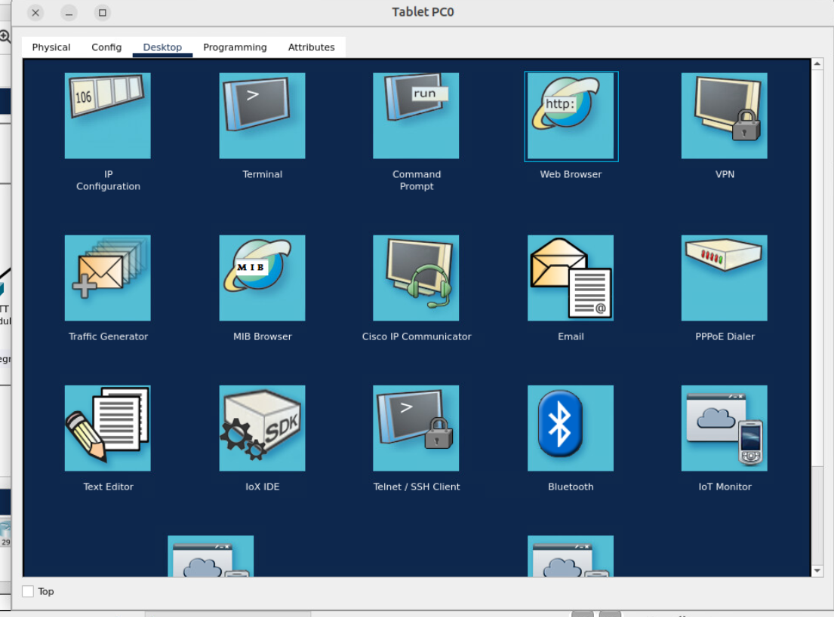

1. Click the web browser and enter IP address 192.168.0.1, this is the default IP address of the Wi-Fi router, then you should see the following logging window.

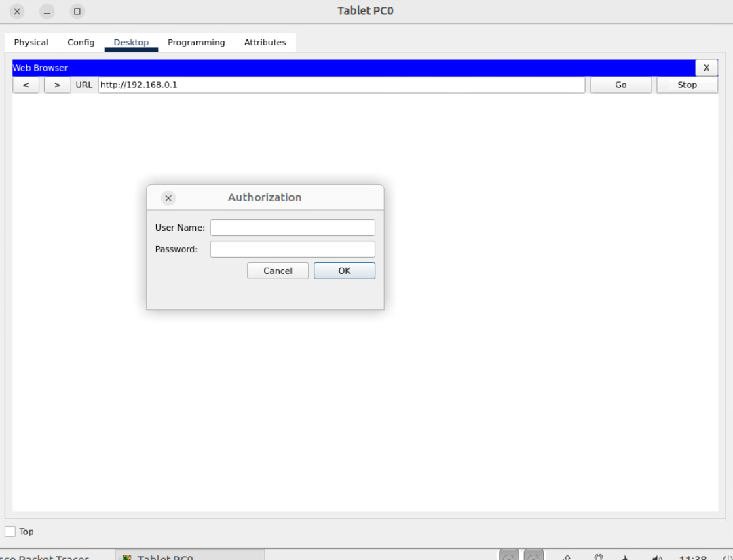

Note that the default credential is : admin/admin.

You should UPDATE the default credential after logging in.

1. You should also UPDATE the firmware after logging in (under the “Administration” tab)

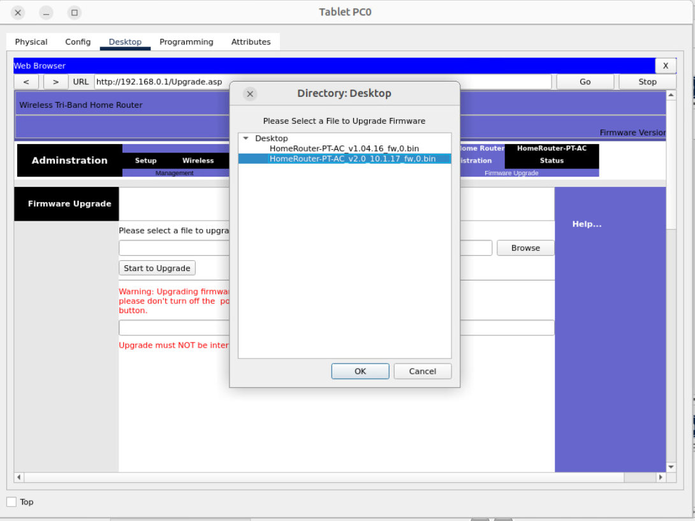

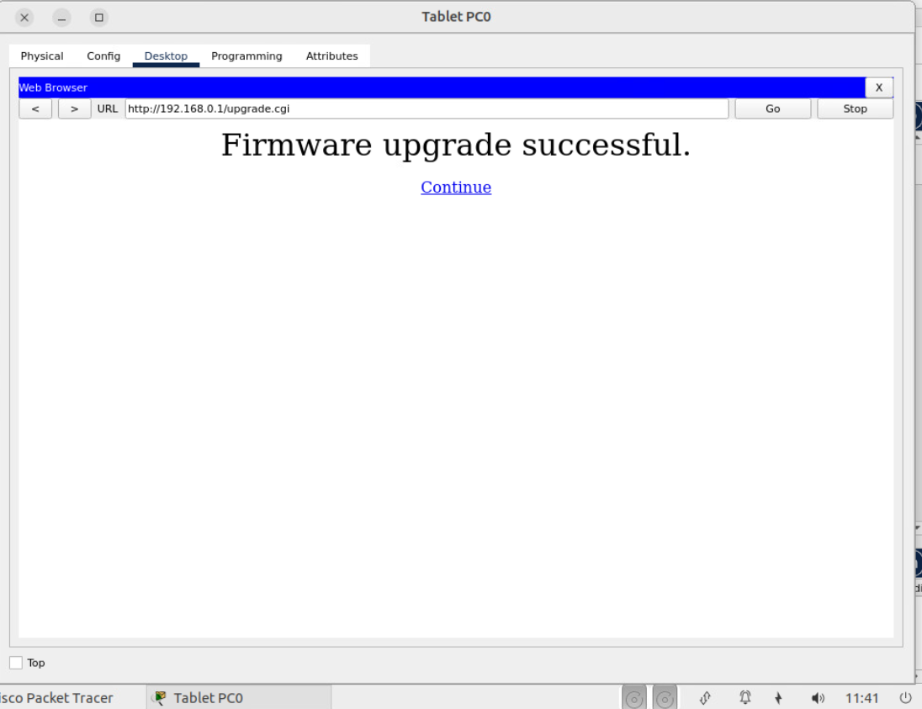

1. A router can connect multiple networks,   
   so for your Wi-Fi router, you should first set up the internet link (WAN link).   
   This is a L3 link, so you need to have an IP address.

Choose different options. Some ISP provide static IP addresses, or you should leave it as DHCP so that the router can obtain an IP address from the ISP.

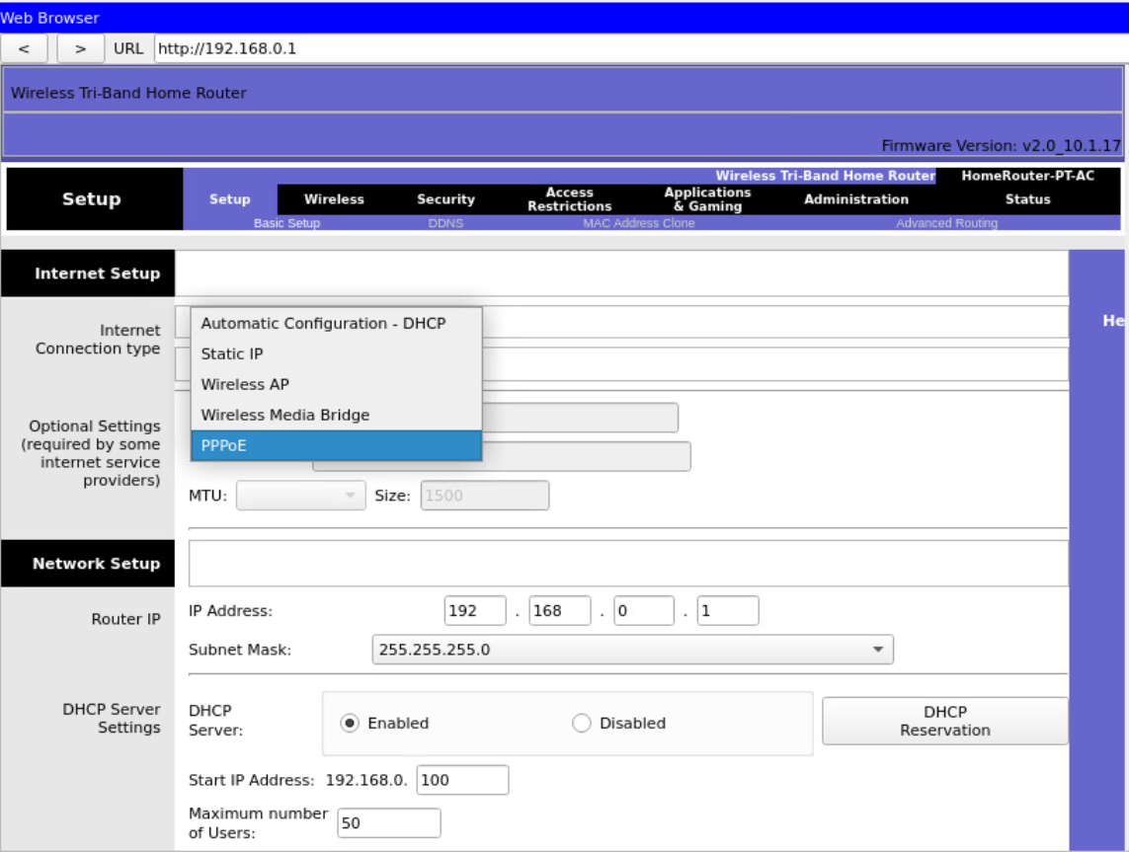

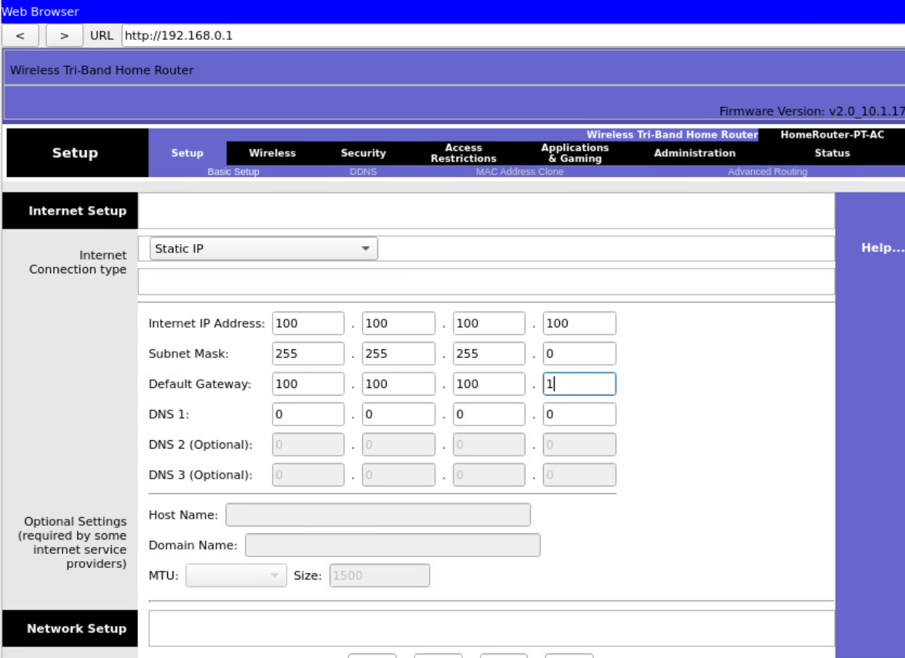

1. Go back to the same tab of IP addressing. In addition to give the Internet link (WAN link) a public IP address, you then should set up IP address for LAN link as well as IP addresses for other users in your local network.

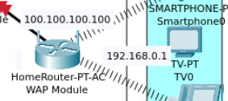

This is done through a DHCP, you need to set up multiple parameters, such as IP address range, subnet mask, Gateway address (the LAN link of the Wi-Fi router), and DNS.

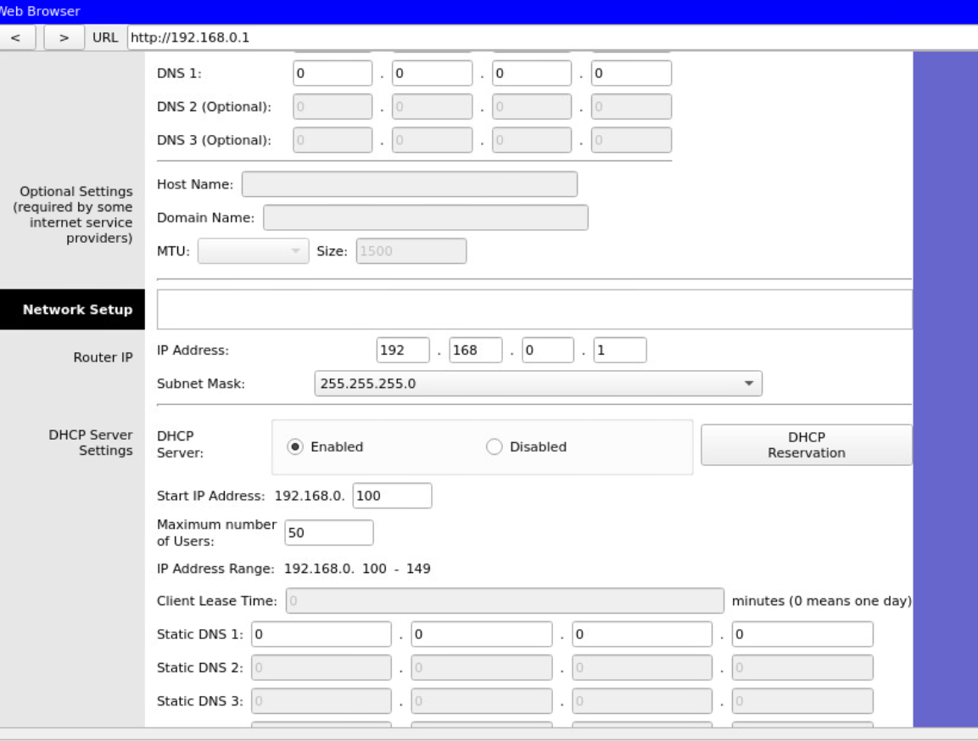

1. You should set up wireless services, including service Identifier (SSID). 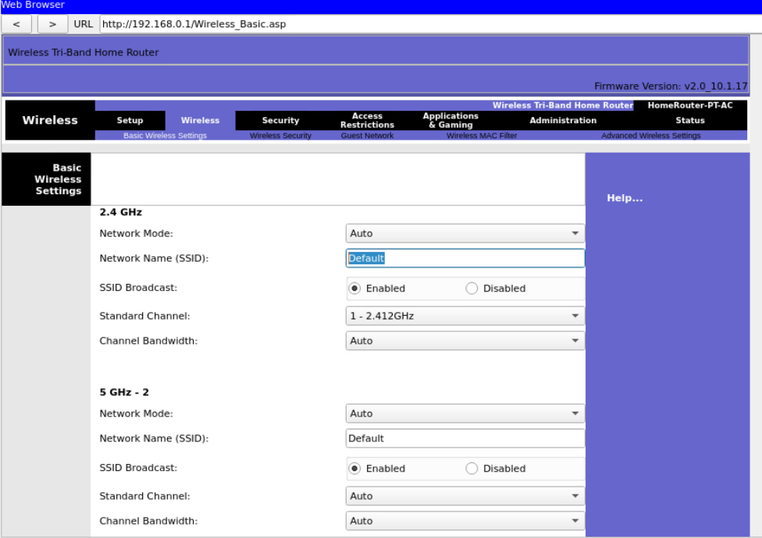

Some organsinations do not broadcast their SSIDs.

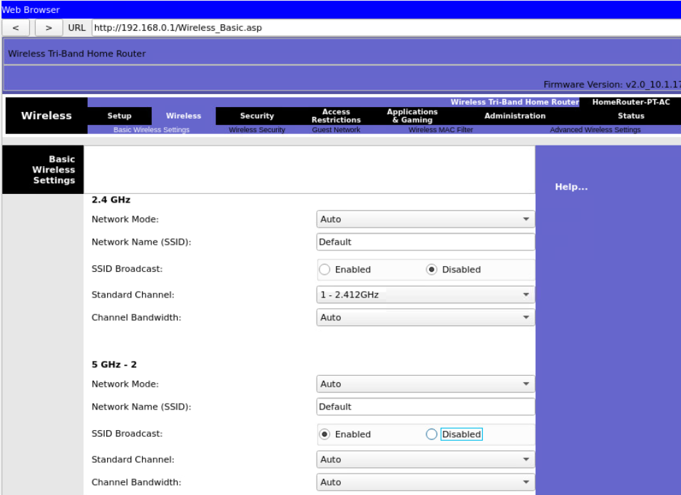

1. Wireless security is critical, you need to set up encryption and authentication. Be aware the difference between WAP versions and options. Do not choose legacy protocol such as WEP.

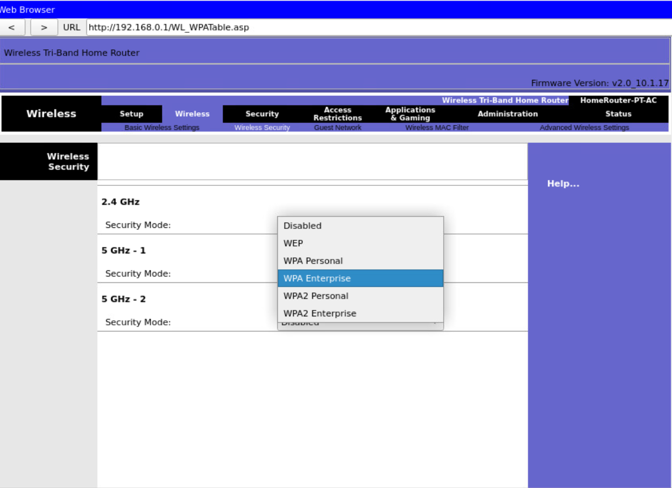

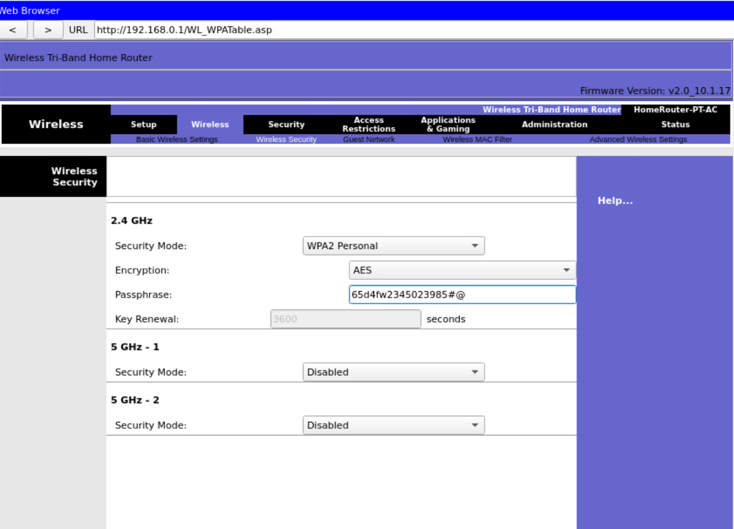

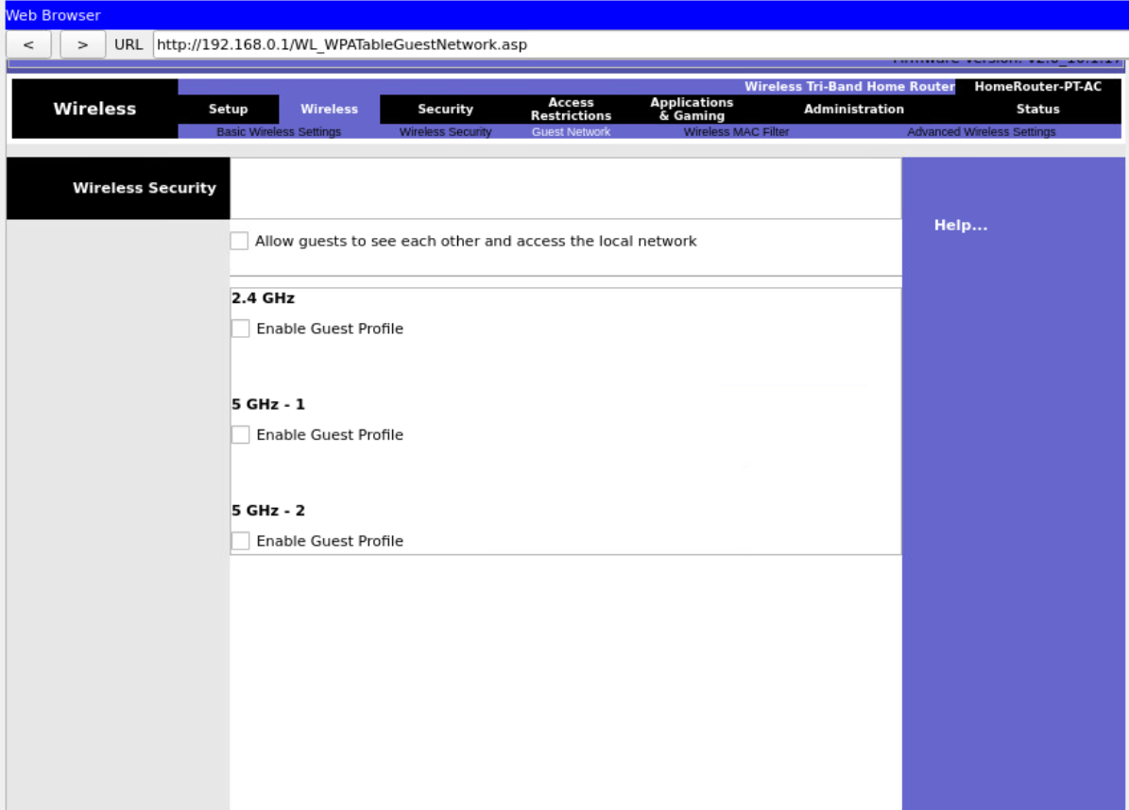

1. Most routers support basic access control or filtering.

Layer 2 access control is based on MAC addresses.

Make sure you understand the outcome of the filter, blocked vs allowed, or black list or white list. You can use a decision tree to work this out.

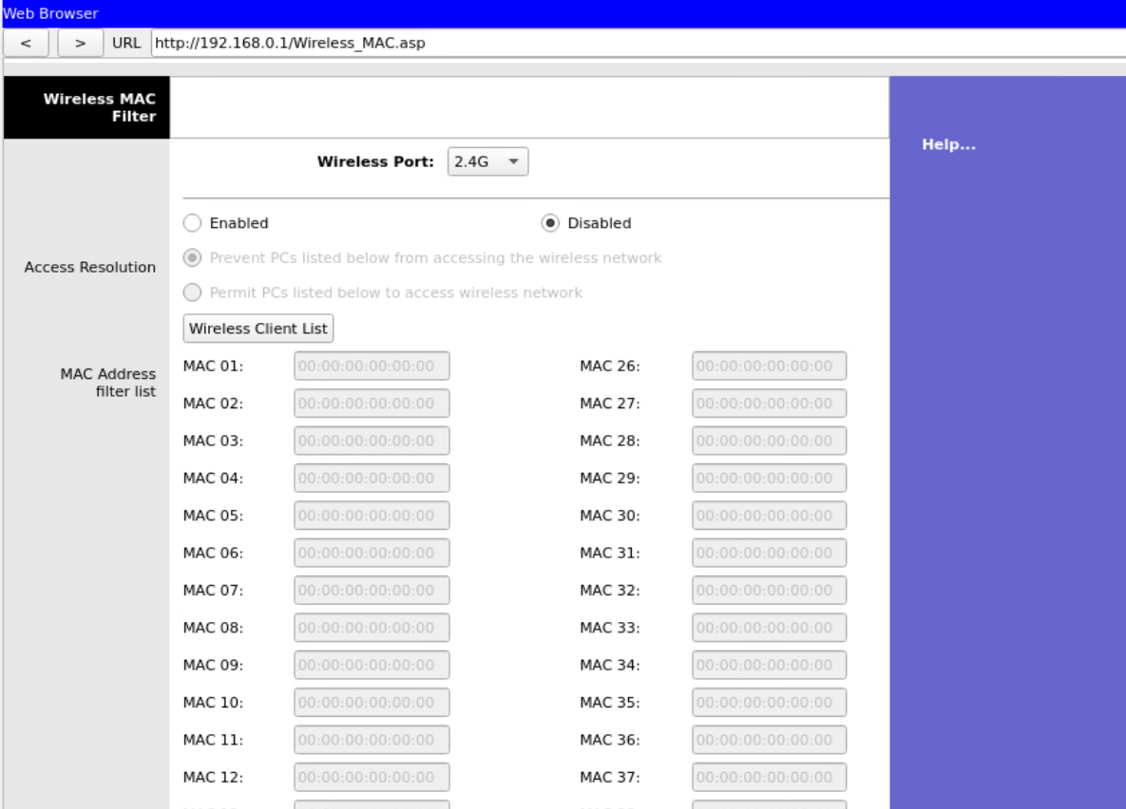

Below shows you how you can find MAC addresses on the wireless/mobile device. Note the format needs to be adjusted (add “:”).

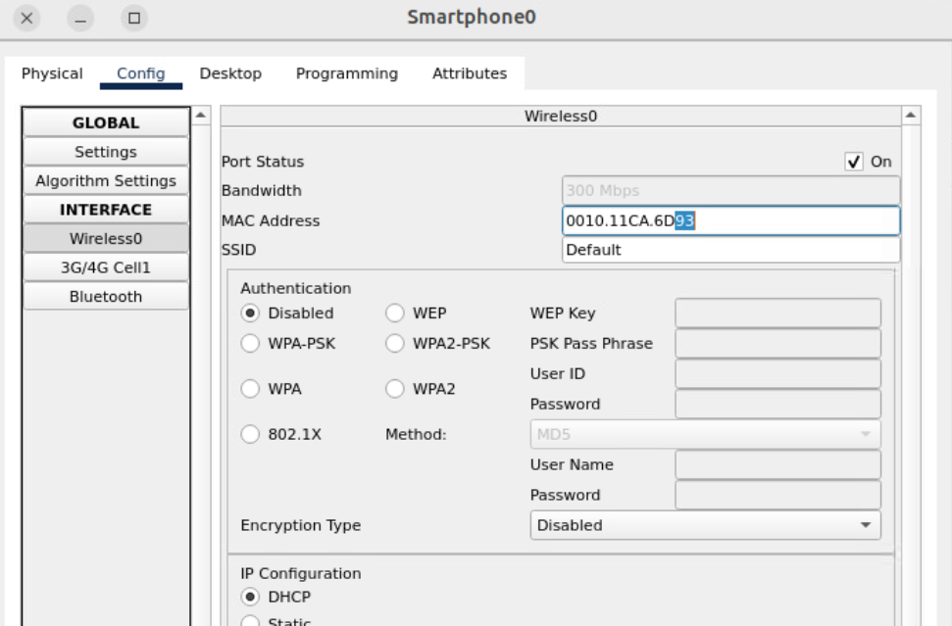

1. You can set up higher level filters based on IP addresses and ports (L3 and L4)

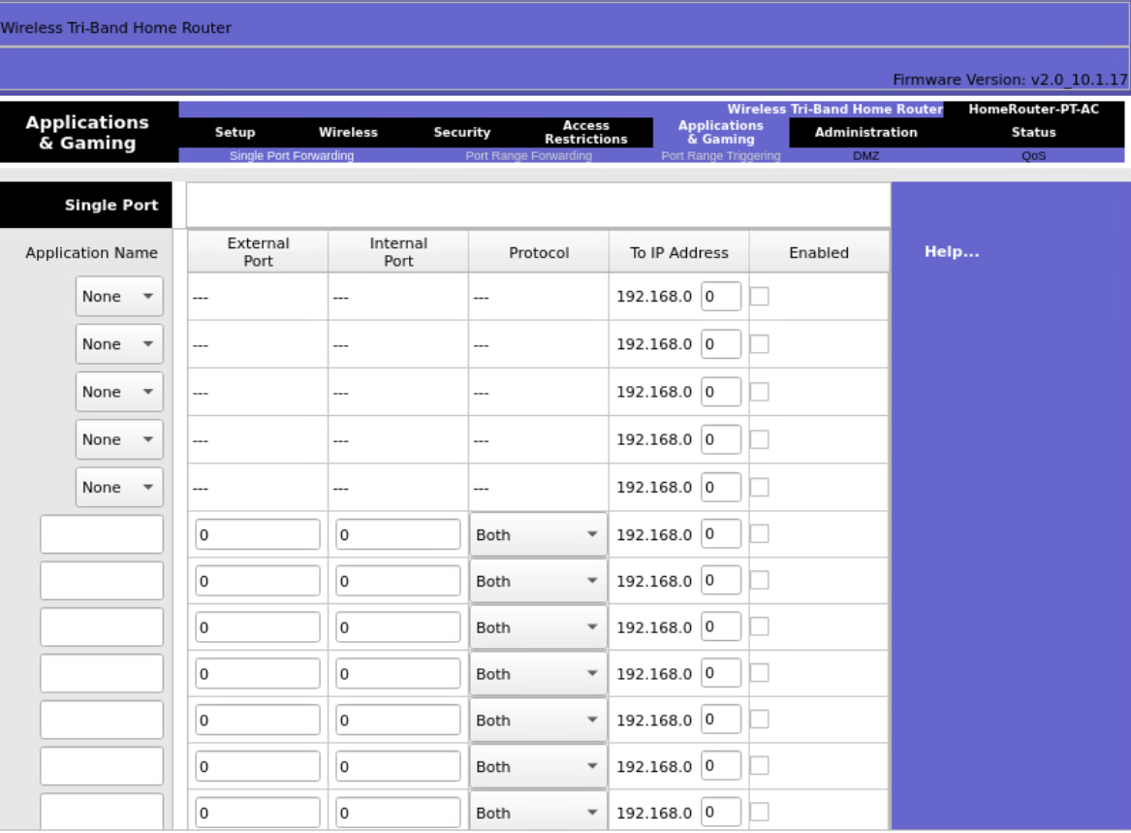

1. You can set up higher level filters based on URLs. Explore more settings.